Purpose of Purchasing Air Knives
To ensure the application of a minimum zinc coating on the strip of 30 g/m² and a maximum of 200 g/m² (total on both sides) at an operating line speed of the Continuous Hot-Dip Galvanizing Line (CHDGL) of not less than 160 m/min.

Information on the Manufactured Products
The Continuous Hot-Dip Galvanizing Line (CHDGL) is used for the production of cold-rolled sheet with a zinc coating.
The products are delivered in coils with the following characteristics:
- Strip width: 800–1250 mm
- Coil inner diameter: 508 or 610 mm
- Coil outer diameter: up to 2200 mm
- Coil weight at entry: up to 30 t
- Coil weight at exit: up to 30 t
- Specific zinc coating mass: 60–350 g/m² (total for both sides)
Steel grades:
08ps, 08Yu (GOST 9045-93), 08, 10, 10ps (GOST 1050-88), ordinary quality, for drawing and deep drawing in coils.
Geometric tolerances:
- Camber: max. 2.0 mm per 1 m length
- Flatness: 30 I-units

Composition and Description of Existing Equipment
The zinc pot is a lined vessel into which zinc, aluminum, and zinc-antimony alloy ingots are fed and melted for the hot-dip galvanizing process. Melting and maintaining the process temperature is achieved using thermal energy supplied by two induction heaters, each rated at 450 kW.
Air knives convert compressed air from the air supply system into a precise and uniform jet directed onto the strip. The air jet removes excess molten zinc, ensuring a uniform coating thickness.
The air knives are located on both sides of the strip passage directly above the zinc pot.
Each air knife assembly includes a nozzle body and a pair of lips.
The nozzle body includes an edge masking system for cross-direction uniformity.
Suspension arms automatically supply air from the main air header to the nozzle.
Each pair of lips consists of a straight lower lip and a profiled upper lip.

Main Zinc Pot Parameters
- Nominal zinc pot volume: 260 tons
- Internal dimensions:
  - Length: 4500 mm
  - Width: 3500 mm
  - Height: 2400 mm
- Power supply capacity: 1100 kVA
- Zinc melt temperature: 450–480 °C

Air Knife System Components
The air knife system includes the following major units:
- Immersion roll/rear stabilizer roll unit
- Front stabilizer roll unit
- Mounting for the driven front stabilizer roll
- Lifting/positioning unit
- Air knife equipment
- Edge mask equipment
- Valve station
- Local control panel
- Main control panel

Lifting/Positioning Unit (Existing at TMZ)
Located above the zinc pot, this unit is a precision mechanism for horizontal and vertical positioning of the air knife assemblies.
Each lifting/positioning unit includes:
- Gear motor with a jacking mechanism for vertical movement of the head and tail sections
- “Up” and “Down” limit sensors
- Position sensors for remote indication
- Two AC gear motors for horizontal adjustment (operator side/drive side, front/rear positions)
- Horizontal position sensors connected to the remote indication system
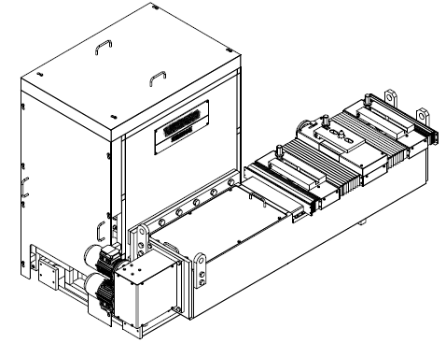

Valve Station (Existing at TMZ)
Installed on the drive side of the line, centered relative to the vertical strip path and located away from the zinc pot edge.
The valve station:
- Includes filters, solenoid valves, pressure regulators, pressure gauges, etc., required for the air knife equipment
- Provides a tapping point for compressed air or other utilities
- Includes flexible hoses and/or cables for supplying media, power, and control signals to the melting section air knife equipment
- Includes the required terminal box
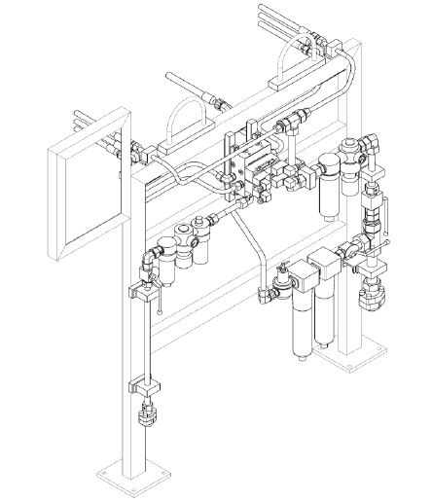

Scope of Supply – Equipment to Be Procured

Air Knives – 2 sets
- Zinc coating range: 30–200 g/m² (total on both sides)
- Nozzle body
- Number of lips (nozzles): min. 8 pcs
- Noise level: —
- Blowing width: up to 1400 mm
- Gap range: 0–2.0 mm
- Gap adjustment: manual
- Wiper: none
- Lip hardness: min. HRC 60
- Lip material: I2363
- Lip coating: Chromium plating ≥ 50 μm
- Replaceable lips: Yes

Nozzle Head Positioning
- Operational rotation relative to horizontal: 10° (−7°/+3°)
- Adjustment type: Hand wheel
- Transmission: Cardan shaft + coupling
- Additional: air hoses and electrical cables included
The supplied equipment must be fully compatible with the existing installation.

Existing Air Blowers at TMZ
- Drive type: Electric motors
- Number of drives: 2 pcs
- Power: 250 kW each
- Speed: Variable (inverter-controlled)
- Frequency inverter: ACS580-07-0505A-4, 3AXD50000041428
- Flow rate: 1800–9000 Nm³/h each
- Pressure: 2000 mbar each
- Quantity: 2 blowers
- Configuration: soundproofed
- Additional information:
  - Starting valve
  - Electronic monitoring and alarm devices

Additional Requirements for Scope of Supply
- Supply of spare and consumable materials for 2 years of operation (supplier to recommend list)
- Technical and operational documentation
- Supervision services, commissioning, and start-up support (“turnkey”)
- Development of process regulations and operating/maintenance instructions
- Metrological documentation (type descriptions, factory test protocols, calibration certificates, conformity certificates, verification procedures, etc.)
- Complete set of fastening/fixing elements and pre-fitted, factory-marked shims
- Blowers must be installed at elevation 0

Power Supply Characteristics
- Electrical parameters:
  - 3-phase AC, 0.4 kV
  - Voltage fluctuation: ±10%
  - Frequency: 50 Hz
  - Frequency fluctuation: ±1%
- Maximum unification of electrical equipment and automation components must be ensured.
- Ingress protection: minimum IP54
- All equipment must be equipped with automatic protection systems for safe shutdown during power outages or voltage dips.
- All cables outside switchgear must be protected from mechanical damage; cables for moving elements must be installed in protective cable chains.

Installation Location
- Sheet-Rolling Shop, Continuous Hot-Dip Galvanizing Line (zinc pot area)

Operating Conditions

Zinc pot area:
Air knife assemblies (left and right) are installed above the zinc melt at 150–500 mm from the melt surface (melt temperature: 450–470 °C).

Blower room:
Indoor installation next to the production area.
Supplier must ensure suitability for local climate.
Seismic activity: up to 8 points.
Indoor climate:
- Minimum winter temperature: −15 °C
- Summer temperature: +50 °C
(Note: seasonal deviations possible)

Equipment Requirements
- Equipment must represent the latest technological standard, providing high technical and economic efficiency. Must be brand-new (manufactured not earlier than 2025).
Exhibition samples or refurbished components are not allowed.
- Dimensions should preferably match existing installation footprints. Blowers must be selected to minimize and optimize energy consumption.
- All external surfaces must be protected against damage/corrosion and painted before shipment.
- Touch-up paint must be supplied.
- Equipment must be designed for maintenance by minimal staff, with simple service procedures taking no more than 20–30 minutes per shift.
- Air knives and blowers must be factory-tested and supplied with certificates.
- Service life before overhaul: 43,200 hours (5 years), 24/7 operation.
- Equipment, pipelines, electrical components, and wiring must be factory-assembled and tested; equipment must be delivered maximally pre-assembled.

Warranty Obligations
The Supplier must guarantee:
- Equipment has passed factory testing and has valid test certificates.
- Equipment is new (produced no more than 365 days before delivery).
- Compliance with modern industrial standards and international quality requirements.
- Full completeness and compliance with country-of-origin standards.
- Warranty period: minimum 3 years until overhaul.
- Supplier must eliminate any non-conformities at its own cost within the contract price.

Marking and Packaging Requirements
A visible nameplate must be installed on the equipment frame with the following information:
- Manufacturer’s trademark
- Equipment name and designation
- Serial number
- Date of manufacture

Personnel Training
- Supplier shall provide training of Customer’s personnel at the Customer’s site during installation and commissioning.
- Training shall include both theoretical and practical modules.

Supervision and Commissioning
Supplier shall provide:
- Installation supervision
- Commissioning works
- Start-up
- Handover of equipment on a turnkey basis

Additional Requirements for the Technical and Commercial Proposal (TCP)
Please include the following equipment and works in the TCP:
- Set of electrical equipment, including:
  - Incoming control cabinet with a drive (variable frequency drive) for the air-knife compressors.
- Set of cables and installation works for connecting the electric motor and control circuits to the incoming control cabinet.
NOTE:
The set of cables and their installation from the connection point to the incoming control cabinet for the air knife drive system is under the responsibility of our company (TMZ).
Please ensure complete compliance of the proposed solution with these requirements.

